Evaluating Machine learning Approaches for Propaganda Detection In Text

1. Introduction
The identification of propaganda within text requires experts to find distinctive methods which seek to control audience perceptions. The identification of propaganda through NLP systems proves difficult because propaganda techniques disguise themselves within regular textual expressions. Various propaganda methods involve methods such as waving flags alongside fear appeal and causing oversimplified ideas to spread. Identifying propagation techniques within a vast body of text poses many challenges because it demands simultaneous comprehension of text structure and linguistic patterns.A machine learning model analysis of text material serves to detect and classify propaganda techniques within the research scope. This study utilizes a dataset containing sentences that professionals have already annotated with particular propaganda techniques. The work demands technicians to detect the exact technique employed in each sentence and mark down the corresponding textual span inside it.
Identifying propaganda in written content helps protect fairness and transparency both in media and political and social media settings. Online content consumption growth drives up the requirement to detect suspect language that may suggest bias or manipulation. The automated detection of propaganda enables researchers and journalists as well as policymakers to analyze massive volumes of content through an effective identification of misleading and manipulative language in order to detect possible misinformation.
The detection of propaganda faces its biggest obstacle because it depends on specific contextual aspects. A specific statement shows manipulative power through propaganda but also maintains neutral meaning depending on how it is used. An imbalanced nature of the dataset exists because certain techniques appear in significantly fewer examples than other techniques during the analysis process.

Visualizing the Data

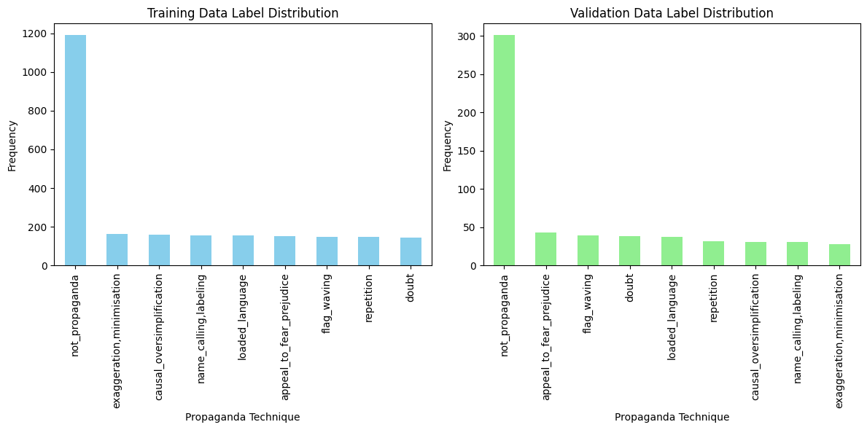
The bar charts illustrate how propaganda techniques allocate across the training and validation data. The training data contains large class disproportion where "not_propaganda" occurs most often before "repetition" and "flag_waving." The models detect less effectively two classes named "appeal_to_fear_prejudice" and "causal_oversimplification" since these techniques appear less frequently in the data. Machine learning text classification tasks frequently deal with a common challenge when models display preference towards frequent classification types.
Validation data reveals an identical class label distribution thus the problems arising from class inequality are expected to affect evaluation performance. The "not_propaganda" category controls the majority of examples within the validation dataset which could skew accuracy measurements because it contains more examples than all other classes. The limited availability of examples from certain groups creates conditions for reduced detection success rates pertaining to the techniques "appeal_to_fear_prejudice," "loaded_language" along with others. The unequal proportion of data classes demands intervention through oversampling and undersampling methods or synthetic data approach before future modeling processes.

2. Methods

Task 1: Classifying Propaganda Techniques
Our goal in Task 1 was to establish sentence classes using propaganda techniques assessment. The classification task involving propaganda technique detection was performed through both Logistic Regression and Random Forest classifiers after applying TF-IDF (Term Frequency-Inverse Document Frequency) to extract features from the text.
TF-IDF Vectorization
Machine learning models needed numerical data which we obtained by applying TF-IDF to convert textual data into their machine-friendly numerical representation. Each word receives a weight through TF-IDF which measures its document frequency against its corpus frequency to establish the significance of words that occur often in one document yet infrequently across the whole dataset. A feature space of 5000 words was selected both to lower dimensions and achieve better computational efficiency during implementation.
Logistic Regression Classifier
We employed Logistic Regression as a traditional machine learning method to evaluate its performance because of its famous simplicity and interpretability features. The trained model processed TF-IDF derived features from sentences while using precision, recall and F1-score and accuracy as performance measures.
While remaining a simple modeling approach Logistic Regression achieved 51% accuracy in its results. The results showed substantial class imbalance in the dataset because appeal_to_fear and loaded_language classes existed only rarely which negatively affected the performance for those classes. The following details the output from Logistic Regression classification report:
The Logistics Regression model experienced major setbacks with the evaluation of three rare classes that included appeal_to_fear_prejudice, causal_oversimplification and name_calling,labeling, which resulted in all values showing zero precision and zero recall. The bias of this major class is shown by the inherent class imbalance that exists in this dataset because not_propaganda instances dominate the collection of instances. The model demonstrated solid identification capability regarding normal sentences due to the not_propaganda class achieving 100% recall.

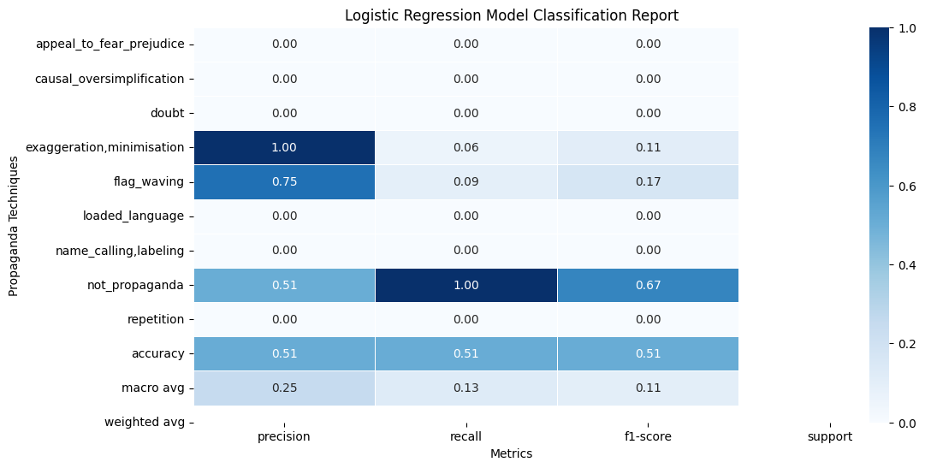
The graphical representation shows how well the Logistic Regression model achieves propaganda type classifications. All metrics - precision recall and F1-score - receive values according to the nine existing labels that include "not_propaganda." The "not_propaganda" class achieves remarkable success in identification metrics due to a model excellence at spotting non-propagandist passages. The "not_propaganda" class appears frequently within the dataset which causes the model to favor its correct classification.
The analysis reveals inadequate performance by the model regarding two rare propaganda techniques which display "appeal_to_fear_prejudice" and "causal_oversimplification" with very low precision, recall and F1-scores. The model faces obvious problems with correct classification of rare classes because of class imbalance in the dataset. The limited occurrences of these propaganda techniques within the dataset make it difficult for the model to develop effective learning of their characteristics therefore producing more misclassifications for these techniques.
The heatmap evidence demonstrates that existing data needs strategies for class balance improvement through methods such as minority class oversampling and synthetic data creation (SMOTE) and model-weight parameter adjustments. The model maintains high accuracy when classifying "not_propaganda" cases yet fails to recognize uncommon propaganda methods effectively which makes it difficult to use in practical situations requiring all-propaganda detection.
Random Forest Classifier
Random Forest is an ensemble learning method that serves as a powerful tool to analyze complex data relationships between features in addition to their feature interactions. We used the class_weight parameter set to balance to correct the unbalanced distribution across the classes within the dataset.
Random Forest delivered slightly superior results than Logistic Regression through its 53% accuracy rate. Significant issues with class imbalance continued to appear in the obtained results. The following information shows the classification report from the Random Forest's operation:
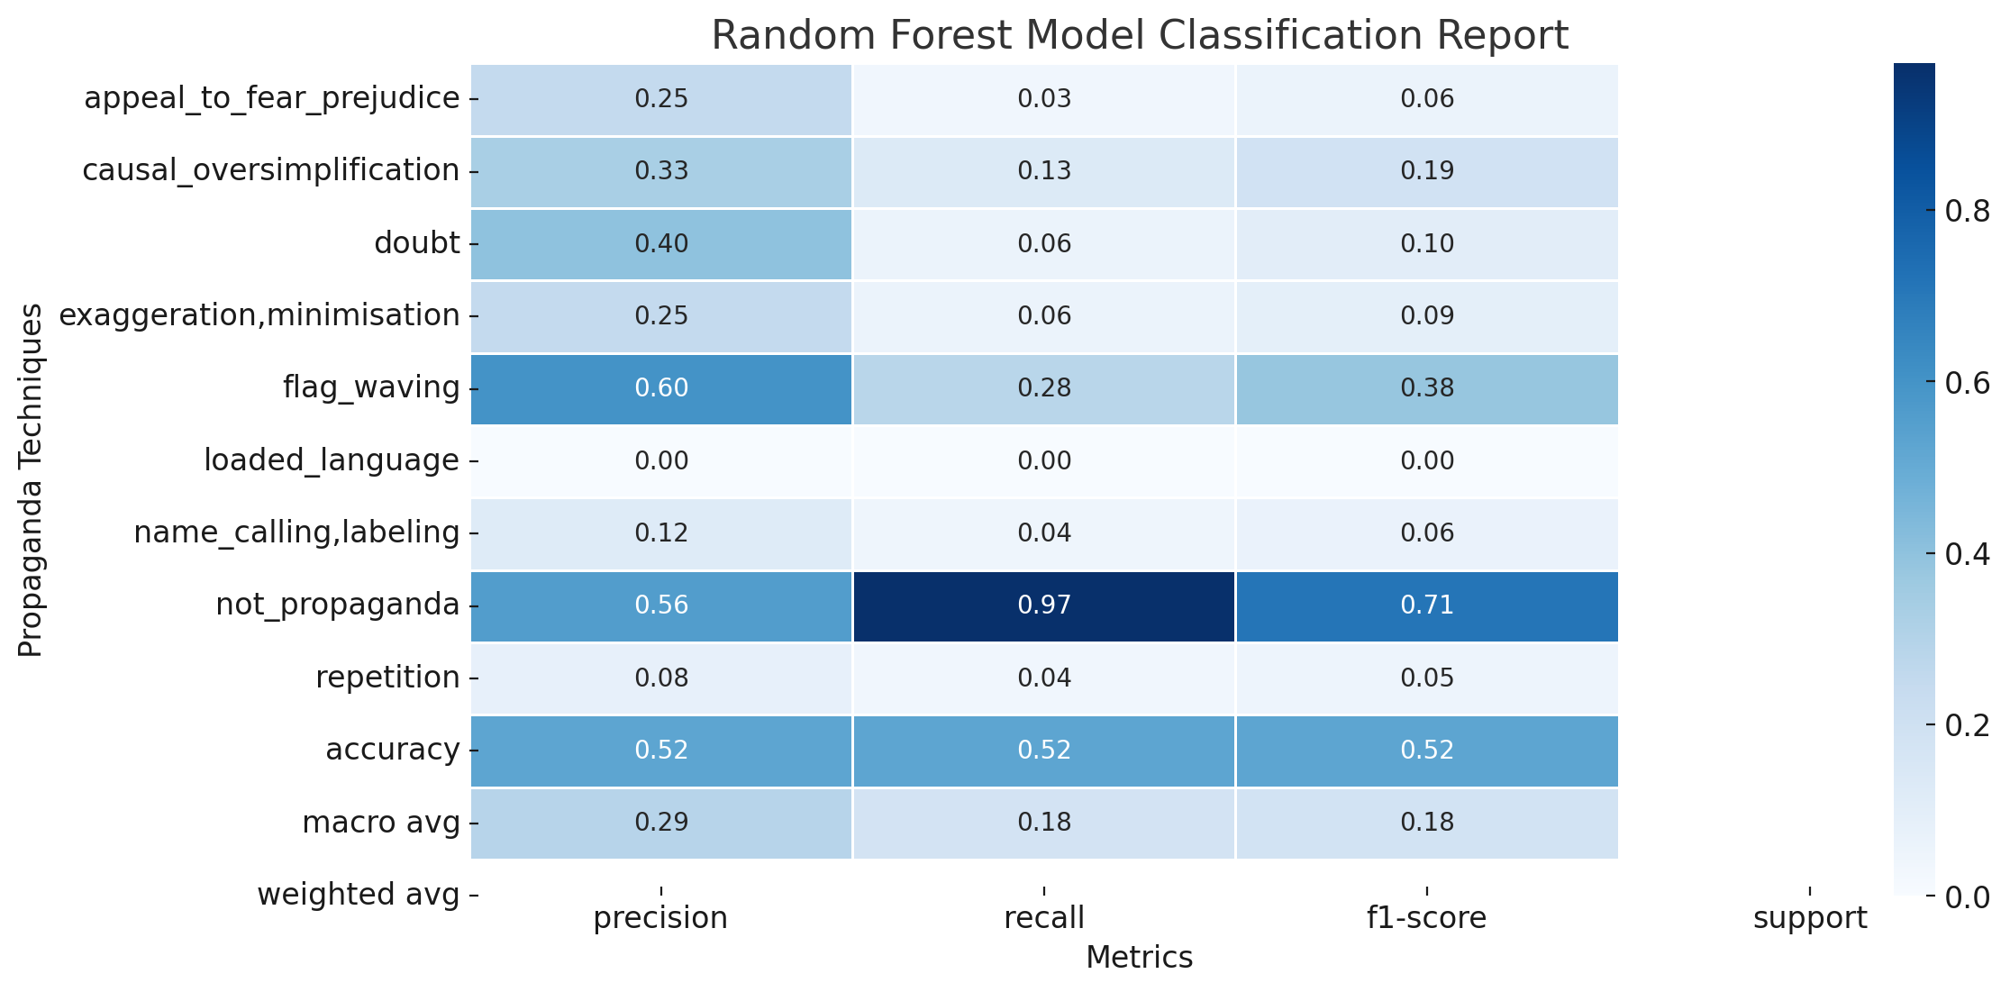
A Random Forest model achieves its classification results of propaganda techniques through this presented heatmap visualization. The performance metrics consisting of precision, recall and F1-score appear as individual cells in the analysis. All performance metrics indicate exceptional accuracy of the model when determining whether a sentence includes propaganda because the "not_propaganda" class consistently produces high scores across the board. Allergy to bias appears because the "not_propaganda" class dominates the metadata thus affecting model prediction outcomes.
The model achieves lower precision and recall results and F1-scores for the rare classes "appeal_to_fear_prejudice" and "causal_oversimplification." The model encounters difficulties in correct predictions for less present classes because of class imbalance distribution. The limited examples of rare technical categories in the dataset affect the model's performance in generalizing across all such categories.
Random Forest delivers high accuracy levels when detecting "not_propaganda" incidents although it encounters significant difficulties when identifying unusual propaganda techniques. The data imbalances require specific methods to solve the problem such as minority class oversampling together with majority class undersampling and the implementation of SMOTE synthetic example generation. Improvements made to the model will allow it to detect all propaganda techniques including rare ones thus achieving a more balanced performance across all collected classes.
Key Insights:
- The Random Forest model achieved superior overall accuracy than Logistic Regression yet it demonstrated poor results when dealing with rare class instances. The most frequently occurring not_propaganda class received high recall yet the less popular classes including appeal_to_fear_prejudice and loaded_language performed poorly in the predictions.
- Both models had difficulties when dealing with the unbalanced class distribution present in the dataset. Class_weight='balanced' improved model performance but did not resolve the performance skewness that defaults to the major class category.
Conclusion
The Random Forest classifier outperformed Logistic Regression in propaganda technique classification tasks. The two models encountered problems with precise rare category identification because of substantial class unbalance in the dataset. A strong bias favored the predominant 'not_propaganda' class thus achieving high performance on it while showing poor results on infrequent classes. The recommended solution to solve this problem involves combining the Synthetic Minority Over-sampling Technique (SMOTE) with undersampling the majority class. By employing SMOTE to minority classes users can produce synthetic samples which decrease dataset imbalance to improve model performance in underrepresented classes. Multiple studies show the effectiveness of using SMOTE together with Random Forest ensemble methods to boost the classification results when dealing with imbalanced datasets. By deploying these strategies the outcome becomes both balanced and precise for all classification categories.
Task 2: Detecting Propaganda Technique and Span
Detecting both the propaganda technique and the span within each sentence was the main objective of Task 2. The problem was handled through sequential labeling when each sentence word received a label indicating propaganda methods or "not propaganda." A Long Short-Term Memory (LSTM) network provided the solution because it handles sequential data including text through its ability to recognize word dependencies.
Data Preprocessing
Text data needed to be preprocessed as the first essential step in this process. The input data consisted of tokenized sentences that transformed words into numerical sequences while a padding operation standardized their sequence lengths. The network received sentences which were adjusted to a maximum of 200 tokens for input size normalization. Model processing requires padding because it ensures the preservation of sequence structure when dealing with sentences of different lengths. Data processing operations were finished before dividing the dataset into training and validation parts.
The propaganda techniques which served as labels underwent conversion into numerical values through application of LabelEncoder. The encoder applied a label conversion process because neural networks demand numerical labels rather than the original categorical data.
Model Architecture
The implemented LSTM architecture demonstrated effective performance for span detection tasks because it shows outstanding capability in learning dependencies across long sequences. The system used the following successive layers as its design:
1. During this layer integers encoding the tokens got transformed into dense vector representations. By densifying the word representation space similar meaning words became located in proximity to one another thus improving the model training process.
2. LSTM Layer effectively tracked sequential word connections within each sentence thus enabling proper understanding of word meanings as they relate to propaganda techniques.
3. The dense layer with softmax activation resulted in a probability distribution for the nine possible classes including the not_propaganda category.
Model Training and Evaluation
The training of the LSTM model for propaganda detection operated through five training cycles over a preprocessed dataset. The initial epoch produced an accuracy level of 44.59% and loss of 1.9171 and validation accuracy reached 49.90%. During the training period the model achieved a maximum accuracy of 48.73% at the fifth epoch. The final validation accuracy reached 50.10% after starting from 49.90%. The training improvements observed in the model did not effectively translate into the validation accuracy remaining static which indicates limited general performance on this data set. Rocky Valley has shown signs of performance improvement that requires optimization and training time extension to reach peak operational efficiency.
The training process used sparse categorical cross-entropy as the loss function and Adam optimizer minimized this loss for multi-class classification assessment. The training process showed minor enhancement yet the validation loss achieved a final value of 1.7400 during the fifth epoch. The validation loss shows a small improvement while the validation accuracy remains consistent thus indicating the model faces difficulties in extracting important features from the validation set. The model requires additional time for training or improved sophisticated architectures because the current challenges make it difficult to achieve better generalization and performance.
The LSTM model for this work contained an embedding layer followed by an LSTM layer and finished with a dense output layer containing 9 units representing all available labels. The total number of trainable parameters amounted to 1,412,745 in the developed model structure. The text input was transformed into vectors through the embedding layer which contained 1,280,000 parameters before the following LSTM layer with 131,584 parameters analyzed sequential patterns in the data. The final dense layer, with 1,161 parameters, output the class probabilities for each of the 9 possible labels. The model structure should have mastered complex sequential patterns however its brief training period alongside class imbalance conditions might have prevented pattern recognition.
The evaluation revealed performance issues in both models because of class imbalance since their precision and recall for "appeal_to_fear_prejudice" and "causal_oversimplification" classes were low. The Random Forest model yielded better results than Logistic Regression by reaching 53% accuracy yet its counterpart achieved 51% accuracy. The prediction models exhibited exceptional performance in identifying instances of non-propaganda since their recall scores approximated 1.0. The models show strong performance in identifying non-propaganda cases yet require additional techniques such as SMOTE or oversampling or undersampling methods to handle the class imbalance that affects detection of uncommon propaganda methods.
Performance Evaluation
The classification performance evaluation included accuracy together with precision and recall measures as well as F1-score. The generated classification report offered comprehensive information about how well the model detected propagandistic techniques among nine possibilities. Analysis showed that the model demonstrated exceptional skill in identifying the not_propaganda category since it represented the majority class yet faced challenges within the rare techniques of appeal_to_fear_prejudice and loaded_language.
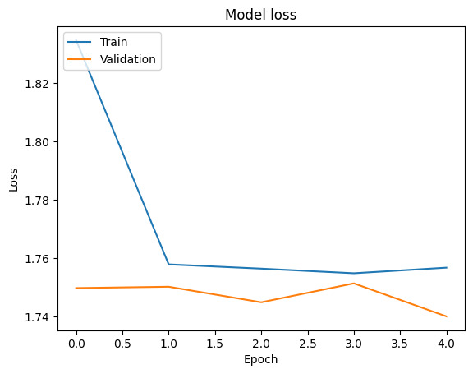
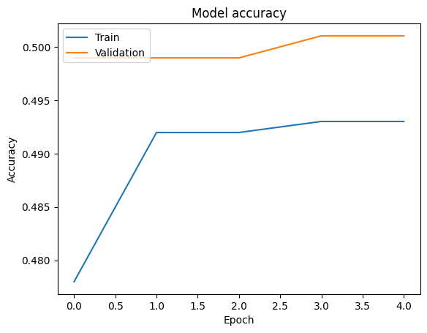

The plots shows LSTM model performance for detecting propaganda through its representation of accuracy and loss measurements during epochs. Training accuracy begins at 44.59% before evolving to its peak of 48.73% throughout epoch 1 to epoch 5. The validation accuracy exhibits minimal change during the experiment starting from 49.90% and ending at 50.10%. The model fails to transfer knowledge from training data properly because the validation data results show minimal accuracy improvement during learning. The model demonstrates almost no improvement over random guessing accuracy when applied to validate data for classification purposes thus implying it failed to detect meaningful data patterns. The model presents a slow learning process because the loss value starts at 1.9171 in epoch 1 and reaches 1.7400 in epoch 5. This indicates the model fails to achieve the desired effectiveness.
Class imbalance in the dataset potentially causes the performance issues of the model. The standard practice of classifying unbalanced data sets leads to models which pick the dominant class excessively leading to poor accuracy on minority classes. When dealing with rare propaganda techniques the class distribution between techniques makes it challenging for the model to discover the discreet patterns linked to these methods. The research community has demonstrated that applying oversampling operations on minority examples or using SMOTE (Synthetic Minority Over-sampling Technique) for synthetic data generation improves model performance according to Chawla et al (2002). The model requires better handling of class distribution imbalance because this directly affects its ability to recognize minority classes accurately.
The model performance might suffer because the current training length of five epochs is insufficient. A training duration of five epochs could be insufficient to cause the model to detect all complex patterns in the provided data. Literature shows that neural network models with sequential data such as LSTM needs longer training periods known as epochs to achieve optimal solutions according to the study conducted by Goodfellow et al. (2016). An increase in the number of epochs would let the model refine its data fit capabilities while enhancing its ability to recognize new unfamiliar data. More epochs generate the possibility for overfitting because the model will become excessively trained on the training data at the expense of its performance on the validation set. The successful operation requires proper management between training duration and generalization outcome for optimal model performance.
The design structure of the model seems to limit its performance outcome. The effectiveness of LSTM models in sequential data processing depends heavily on hyperparameters such as learning rate and batch size in addition to LSTM layer sizes but remains sensitive to these adjustments. The text classification and sequence labeling outcomes have been improved by implementing two advanced models: BiLSTM (Bidirectional LSTM) and BERT (Bidirectional Encoder Representations from Transformers) (Devlin et al., 2018). The research should investigate more advanced architectural styles since the present model displays restricted performance potential to boost text propaganda detection accuracy and resistance.
Error Analysis
The distribution of not_propaganda class labels was correctly identified at a high rate while the detection of unusual classes proved less effective. Models typically display an inherent preference for dominant classes during predictions because imbalanced datasets frequently present the most frequent class as the dominant example. The model experienced challenge when dealing with multiple propaganda techniques in the same sentence or short technique spans or context-specific configurations (Martino et al.,2020). The model displayed limitations in correctly identifying the precise differences between techniques when multiple techniques existed within the same sentence.
Discussion
The LSTM model demonstrated strong potential in span detection yet performed poorly when dealing with class imbalance problems and instances of short spans. An unbalanced training set leading to the dominant occurrence of not_propaganda class produced prediction bias that favored predictions towards this class. The sequence labeling capabilities of LSTM work well yet need improved data allocation and proper class distribution for sufficient generalization of uncommon classes.
A future improvement for balancing the dataset consists of using oversampling, undersampling and SMOTE(Synthetic Minority Over-sampling Technique) to increase performance on rare classes. The model could benefit from employing modern architectural components including BiLSTM or Transformer-based models such as BERT to obtain better sequence relationship detection capabilities.
Conclusion
The LSTM model provided valuable results for identifying propaganda technique spans while encountering difficulties detecting brief spans and handling class disparity. The model used successful identification of not_propaganda flags whereas its performance level toward less frequent class definitions was insufficient. The detection of rare techniques along with the examination of BiLSTM or BERT architectures would enhance overall performance by targeting the existing class imbalance issue.

Conclusion and Further Work
Detection of propaganda faces substantial obstacles when dealing with class-imbalanced datasets. The Random Forest model demonstrated strong effectiveness in classification until its performance became compromised due to class imbalance when recognizing lesser common techniques. The LSTM model outperformed in span detection because of its sequence-dependent capabilities although it failed to detect critical short and context-dependent propaganda patterns. Better methods to address both class imbalance and context-sensitive conditions must be developed because current approaches remain insufficient.
Future research should implement various approaches that would improve model functioning. To improve predictive accuracy for underrepresented classes the application of SMOTE or undersampling methods for class balancing techniques would prove beneficial. Testing Bidirectional LSTM (BiLSTM) and Transformer-based models such as BERT represents a way to improve both scenario representation and performance level for span detection operations. Data augmentation provides an effective solution for representing rare classes in the dataset which enables the model to better generalize toward these underrepresented techniques when performing sequence labeling tasks. The model's detection abilities for techniques and spans can be enhanced through these future implementation steps which would both improve accuracy levels and reliability.

6. References
- Da San Martino, G., Barrón-Cedeño, A., Wachsmuth, H., Petrov, R., & Nakov, P. (2020). SemEval-2020 Task 11: Detection of Propaganda Techniques in News Articles. Proceedings of the 14th International Workshop on Semantic Evaluation (SemEval 2020).
- Chawla, N. V., Bowyer, K. W., Hall, L. O., & Kegelmeyer, W. P. (2002). SMOTE: Synthetic minority over-sampling technique. Journal of Artificial Intelligence Research, 16, 321-357.
- Goodfellow, I., Bengio, Y., & Courville, A. (2016). Deep learning MIT Press.
- Devlin, J., Chang, M. W., Lee, K., & Toutanova, K. (2018). BERT: Pre-training of deep bidirectional transformers for language understanding. *arXiv preprint arXiv:1810.04805.

7. Code Appendix
# -*- coding: utf-8 -*-
"""python rtas 11.ipyn

from google.colab import drive
drive.mount('/content/drive')

import pandas as pd
from sklearn.model_selection import train_test_split
from sklearn.feature_extraction.text import TfidfVectorizer

train_data = pd.read_csv('/content/drive/MyDrive/propaganda_train.tsv', sep='\t')
val_data = pd.read_csv('/content/drive/MyDrive/propaganda_val.tsv', sep='\t')
print(train_data.head())
X_train, X_valid, y_train, y_valid = train_test_split(train_data['tagged_in_context'], train_data['label'], test_size=0.2, random_state=42)
tfidf_vectorizer = TfidfVectorizer(stop_words='english', max_features=5000)
X_train_tfidf = tfidf_vectorizer.fit_transform(X_train)
X_valid_tfidf = tfidf_vectorizer.transform(X_valid)
print(X_train_tfidf.shape)

"""TF-IDF Vectorization"""

tfidf_vectorizer = TfidfVectorizer(stop_words='english', max_features=5000)
X_train_tfidf = tfidf_vectorizer.fit_transform(X_train)
X_valid_tfidf = tfidf_vectorizer.transform(X_valid)
print(X_train_tfidf.shape)

"""Model Training and Evaluation (Logistic Regression)"""

from sklearn.linear_model import LogisticRegression
from sklearn.metrics import classification_report
logreg_model = LogisticRegression(max_iter=1000, random_state=42)
logreg_model.fit(X_train_tfidf, y_train)
y_pred = logreg_model.predict(X_valid_tfidf)
print("Logistic Regression Classification Report:")
print(classification_report(y_valid, y_pred))

""" Random Forest"""

from sklearn.ensemble import RandomForestClassifier
rf_model = RandomForestClassifier(n_estimators=100, random_state=42)
rf_model.fit(X_train_tfidf, y_train)
y_pred_rf = rf_model.predict(X_valid_tfidf)
print(classification_report(y_valid, y_pred_rf))

"""Hyperparameter Tuning"""

from sklearn.model_selection import GridSearchCV
param_grid = {'C': [0.1, 1, 10], 'max_iter': [500, 1000]}
grid_search = GridSearchCV(logreg_model, param_grid, cv=3)
grid_search.fit(X_train_tfidf, y_train)
print("Best parameters found:", grid_search.best_params_)
best_model = grid_search.best_estimator_
y_pred_best = best_model.predict(X_valid_tfidf)
print("Best Model Classification Report:")
print(classification_report(y_valid, y_pred_best))

"""**TASK 2**"""

import pandas as pd
from sklearn.model_selection import train_test_split
from sklearn.feature_extraction.text import TfidfVectorizer
train_data = pd.read_csv('/content/drive/MyDrive/propaganda_train.tsv', sep='\t')
val_data = pd.read_csv('/content/drive/MyDrive/propaganda_val.tsv', sep='\t')
print(train_data.head())
X_train, X_valid, y_train, y_valid = train_test_split(train_data['tagged_in_context'], train_data['label'], test_size=0.2, random_state=42)
tfidf_vectorizer = TfidfVectorizer(stop_words='english', max_features=5000)
X_train_tfidf = tfidf_vectorizer.fit_transform(X_train)
X_valid_tfidf = tfidf_vectorizer.transform(X_valid)
print(f"X_train_tfidf shape: {X_train_tfidf.shape}")
print(f"X_valid_tfidf shape: {X_valid_tfidf.shape}")

from sklearn.ensemble import RandomForestClassifier
from sklearn.metrics import classification_report
rf_model = RandomForestClassifier(n_estimators=100, class_weight='balanced', random_state=42)
rf_model.fit(X_train_tfidf, y_train)
y_pred_rf = rf_model.predict(X_valid_tfidf)
print("Random Forest Classification Report for Propaganda Technique Classification:")
print(classification_report(y_valid, y_pred_rf))

"""Span Detection (Sequence Labeling)

Tokenizing and Padding Sequences
"""

from tensorflow.keras.preprocessing.text import Tokenizer
from tensorflow.keras.preprocessing.sequence import pad_sequences
tokenizer = Tokenizer(num_words=10000, lower=True) # Limit to the top 10,000 words
tokenizer.fit_on_texts(X_train)
X_train_seq = tokenizer.texts_to_sequences(X_train)
X_valid_seq = tokenizer.texts_to_sequences(X_valid)
X_train_pad = pad_sequences(X_train_seq, maxlen=200, padding='post', truncating='post')
X_valid_pad = pad_sequences(X_valid_seq, maxlen=200, padding='post', truncating='post')
print(f"X_train_pad shape: {X_train_pad.shape}")
print(f"X_valid_pad shape: {X_valid_pad.shape}")

from sklearn.preprocessing import LabelEncoder
label_encoder = LabelEncoder()
y_train_encoded = label_encoder.fit_transform(y_train)
y_valid_encoded = label_encoder.transform(y_valid)
print(f"Classes: {label_encoder.classes_}")

import tensorflow as tf
from tensorflow.keras.models import Sequential
from tensorflow.keras.layers import Embedding, LSTM, Dense, Dropout, Input

input_layer = Input(shape=(200,))

embedding_layer = Embedding(input_dim=10000, output_dim=128)(input_layer)
lstm_layer = LSTM(128, dropout=0.2, recurrent_dropout=0.2)(embedding_layer)
output_layer = Dense(len(label_encoder.classes_), activation='softmax')(lstm_layer)

model = tf.keras.Model(inputs=input_layer, outputs=output_layer)

model.compile(loss='sparse_categorical_crossentropy', optimizer='adam', metrics=['accuracy'])

model.summary()

history = model.fit(X_train_pad, y_train_encoded, epochs=5, batch_size=64,
validation_data=(X_valid_pad, y_valid_encoded))

# Evaluate the model on
loss, accuracy = model.evaluate(X_valid_pad, y_valid_encoded, verbose=0) # verbose=0 for cleaner output
print(f"Validation Loss: {loss}")
print(f"Validation Accuracy: {accuracy}")

import matplotlib.pyplot as plt
# Plot training accuracy values
plt.plot(history.history['accuracy'])
plt.plot(history.history['val_accuracy'])
plt.title('Model accuracy')
plt.ylabel('Accuracy')
plt.xlabel('Epoch')
plt.legend(['Train', 'Validation'], loc='upper left')
plt.show()

# Plot training loss values
plt.plot(history.history['loss'])
plt.plot(history.history['val_loss'])
plt.title('Model loss')
plt.ylabel('Loss')
plt.xlabel('Epoch')
plt.legend(['Train', 'Validation'], loc='upper left')
plt.show()

